Miami Lib Finder

Planning Document

|  |  |
| --- | --- |
| Primary Author: | Yixin Li |
| Contributors: | Yi Yang, Yangkai Zhang, Wenkai Cao |

**ACCEPTANCE:**

|  |  |  |
| --- | --- | --- |
| Sponsor/Client: | Mattew Benzing | [10/20/2019] |
| Team Representative: | Yixin Li | [10/20/2019] |
| others | Yi Yang, Yangkai Zhang, Wenkai Cao | [10/20/2019] |

**Table of Contents**

**Charter [Yangkai Zhang]** **3**

**Problem Domain [Yangkai Zhang & Yixin Li]** **4**

**Scope of Work [Yi Yang]** **4**

**Roles and Responsibilities [Yi Yang]** **5**

**Communication Plan [Wenkai Cao]** **6**

**Development Methodology [Wenkai Cao]** **7**

**Testing Methodology [Yixin Li]**

**Revision History**

|  |  |  |
| --- | --- | --- |
| **Revision** | **Changes** | **Date** |
| **Draft 1** | **Baseline** | **09/20/19** |
| **Draft 2** | * **Charter: Project Objective** * **Problem Domain** * **Scope of Work** * **Design Artifacts** * **Requirement Specification** * **Going Forward** | **10/25/19** |

## Charter

## Yixin Li

|  |  |
| --- | --- |
| **PROJECT OBJECTIVE** | |
| Problem Statement or Business Need | Users have trouble finding a resource in the library. |
| Purpose of Project: | Guiding the user to the target location. |
| Business Case: | Indoor Navigation System will not charge any money for Miami University’s Students and Faculties. |
| Goals/Metrics: | The User could use the app to find the exact book’s area or items location at King Library. |

|  |  |
| --- | --- |
| **PROJECT STAKEHOLDERS** | |
| Project Sponsor: | Benzing Mattew - librarian,benzinmm@miamioh.edu |
| Sponsor Delegate | Meng Qu - librarian, [qum@miamioh.edu](mailto:qum@miamiogh.edu) |
| Project Team | Yixin Li - [liy111@miamioh.edu](mailto:liy111@miamioh.edu)  Wenkai Cao [- caow2@miamioh.edu](mailto:-caow2@miamioh.edu)  Yangkai Zhang - [zhangy68@miamioh.edu](mailto:zhangy68@miamioh.edu)  Yi Yang [- yangy37@miamioh.edu](mailto:-yangy37@miamioh.edu) |
| other stakeholders? | Vaskar Raychoudhury [- raychov@miamioh.edu](mailto:-raychov@miamioh.edu) Vaskar Raychoudhury is the instructor of M3 mapper, we need technology and data of the group. |

|  |  |
| --- | --- |
| **PROJECT TIMELINE FALL 2019** | |
| Expected Start Date: | Oct 20,2019 |
| MILESTONE 1 (11/ 20) | Have a reactive interface without navigating function |
| MILESTONE 2 (11/20) | Basic navigating algorithm design is done |
| Expected Completion Date: Dec 5, 2019 | Semester Presentation: Miami Lib Finder  What's included:  What we did this year;  How's it conducted:  The user interface and navigation algorithm working on the Android Emulator  Who should attend?  Our project team, instructor and client*.* |

## **Problem Domain** Yangkai Zhang & Yixin Li

In Miami University, those who go to the library have trouble finding the book, restroom and so on. The current solution is to ask the front desk for help. However, the librarians are limited and may be busy. Our application provides navigation services to help the user locate the book and generate optimal routes. This project is worth doing because it satisfies the student and faculty requirements. It makes their work more conveniently.

There are many technology constraints for our team, the knowledge domain of this project is out of our knowledge base, such as create a mobile app, implement a new algorithm for the unique use (mapping a target within a building), and find a way of transferring map into a grid map (as usable data for our algorithm). Another potential huge constraint might be the performance of hardware, since our plan of the first semester is building an application that computes everything on a smartphone, not just sending and requesting data from server, thus the software optimization would be a serious task for us (usually a computer is significant powerful than a smartphone). Also database is one of our certain obstacles in the future, although we have learned the database from CSE 385, the real database for a mobile terminal is totally distinctive from general SQL database.

For technology risk, based on current access point data, no one of our team can confirm that the AP data from CISCO cmx system is one hundred percent accurate. And there might be many potential security issues associated with mobile development.

## Scope of Work Yi Yang

**In-Scope**

* A* Algorithm Implement (building our unique algorithm based on concepts of A*)
* Grid Mapping System
* Product Decomposition Diagram
* Cisco System Json Analyze
* DWG Format File Implement
* Picture Selection and Painting for User Interface

**Outside of Scope**

* Identify Personal Position
* CAD Data Collection
* Book Information Collections

**Expected Deliverables:**

**Required Course Deliverables:**

1. Project Plan
2. RACI (Risks, Assumptions, Constraints, Issues) Log
3. User Guide [449]
4. Developer’s Guide, including detail design documentation
5. Installation Guide [449]
6. Source Code [449]
7. Meeting Agendas and Minutes
8. Status Reports

## Roles and Responsibilities Yi Yang

|  |  |
| --- | --- |
| Mattew Benzing  **Sponsor/Client**  benzinmm@miamioh.edu | Provide an accurate and consistent set of requirements.  Be available for meetings and issue resolution. |
| Yixin Li **Team Lead**  liy111@miamioh.edu | Responsible for the supervision of all members doing work. |
| Yangkai Zhang  **Schedule Lead**  zhangy68@miamioh.edu | Responsible for the overall schedule and its accuracy. |
| Wenkai Cao  **Quality Checker**  caow2@miamioh.edu | Responsible for the code is deliverable |
| Yi Yang  **Faculty Mentor**  yangy37@miamioh.edu | Responsible for contact faculty for all the issues. |

**Shared Team Responsibilities:**

The following activities and related artifacts will be shared by the team.

Must be Shared by Team:

Status Reports: Report for each Kick-off meeting and client meeting.

Meeting Minutes: Note for every kick-off meeting and client meeting.

Assignment submissions : Request for each assignment.

Personal Status Reports: Personal Report for each Kick-off meeting and client meeting.

Related artifacts: The article that each group member should study for.

RACI Log: Depending on the project, the Risk Assumptions Constraints and Issues Log may be used intermittently.

Self-Task Plan: Identifies the deliverables for each iteration.

## Communication Plan Wenkai Cao

**Meetings**:

* Status Meeting with Pro. Stahr: Monday 2:30 pm to 3:00 pm for every two weeks
* Meeting with Dr. Vaskar: Thursday 12:00 pm to 1:00 pm every week
* Meeting with Client Benzing: TBD. The group and client will have meetings when needed. For example, if the code plan and client requirements have conflict, group members will send emails to the client and ask for a meeting to discuss.
* Meeting with Sponsor Meng Qu: Monday 3:00 pm to 4:00 pm for every week

**Communication Types**:

* Email: Team leader: Yixin Li liy111@miamioh.edu

Schedule leader: Yangkai Zhang zhangy68@miamioh.edu

## Development Methodology Wenkai Cao

**Methodology:**

We will use Agile development for this project. Because agile development is based on the user’s requirements. In addition, we will divide the large projects into small projects to assign work to group members. And we will encourage our to participate as the user in the entire process of project development, through user’s feedback, the project is more in line with the changing needs of users, and also to make sure what is our client request.

**Programming Style Guidelines:**

There are four main rules of the program style, keep it simple, strive for clarity, be consistent and follow other well-established standards. In this program, our main language is C#. The reference we use to guide the style of the program is <https://docs.microsoft.com/en-us/dotnet/csharp/programming-guide/inside-a-program/coding-conventions>. We will follow the official advice of the program style of C# to make all codes look good.

## Testing Methodology Yixin Li

We will update our code and do version control by the GitLab tool. Identify version via a decimal number from 0 to 1(increment by 0.01), the great progress may increase version number significantly.

**There are two main phases of testing our validated software:**

(phase two starts only if phase one is finished)

**Phase one:** Test the functions of software by virtual verifiable data, such as start position and destination. And then measure the quality of navigation by path distance, complexity, and running time. The test details and documentation will be placed in the shared drive when ready to run any test.

**Phase two:** Run the software in real-time, and interact with the server to get the location of the user. Test it on the phone and in the King library.

For user acceptance testing, it will be tested in both phases, because the accuracy of tracking location is something out of control in this project, we need to make sure that the software is usable under the virtual environment to control the overall quality.

## Design Artifacts Yang Yi & Yixin Li

This project will include navigation within the library (from current location to desired location). We will embed the library map in the final software. However, in the end our finished product will only contain navigation from the library rather than other locations within the school. In the coming months, we will gradually improve the architecture of the entire software. From basic point-to-point navigation to navigation on the actual map. So far, we have no other budget except for some licenses for the necessary software. If we receive a new request from a customer, we will respond on the same day and make changes within a week.

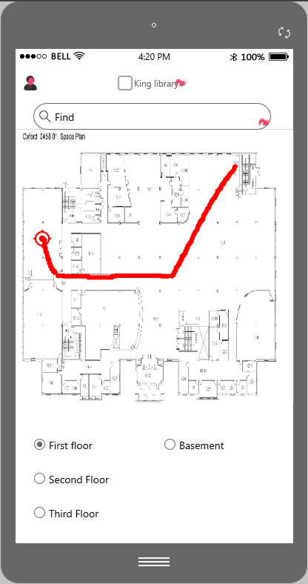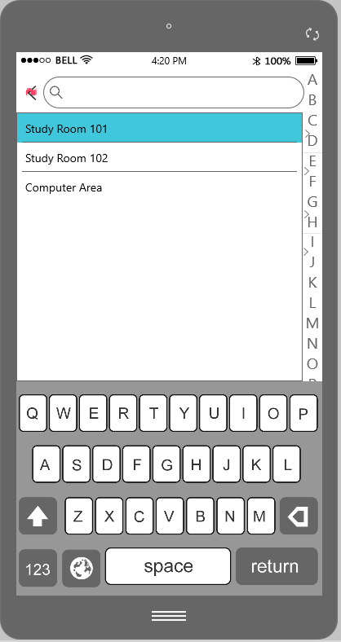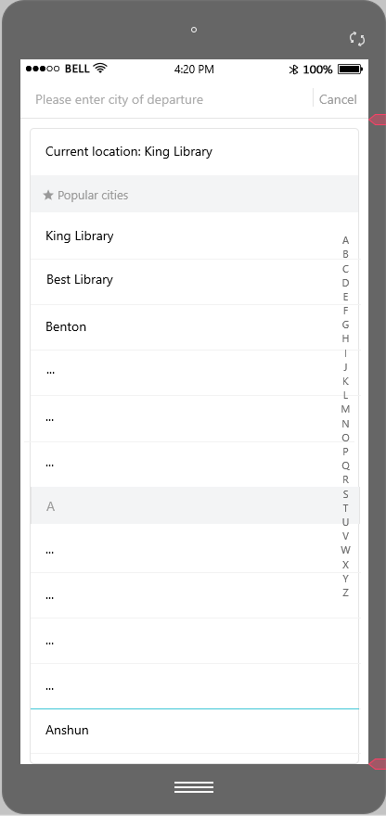

## **Requirements Specification** Yangkai Zhang

Using Trello to release our tasks and record of the project.

Trello:<https://trello.com/b/ztjLGNLd/miami-lib-finder>

## **Going forward** Yixin Li

For next semester, the most crucial thing for our project is to integrate every piece we have implemented together, such as algorithm, pathline mapping, functions of interactive user interface and database. After that, we will only focus on integration testing, for instance, we need to make sure our map is likely precise as the real map as possible, the special tests are required to bring our devices to the King library and gather data. Therefore, the last section will be heavily testing and product improvement.